TEAM 1 - ROUTE OPTIMIZATION & DEMAND FORECASTING

INTRODUCTION
Efficient transportation and logistics systems are essential for reducing operational costs, minimizing environmental impact, and ensuring timely service delivery. With increasing urban congestion and rising demand variability, traditional static routing methods are no longer sufficient to handle real-world logistics challenges.
Demand forecasting plays a critical role by predicting when and where transportation demand will occur based on historical data and temporal patterns. Accurate demand predictions allow organizations to proactively allocate resources, reduce idle trips, and prevent service delays.
Route optimization, on the other hand, focuses on identifying the most efficient paths for vehicles by minimizing travel time, fuel consumption, and carbon emissions while meeting delivery constraints. Effective routing decisions depend heavily on accurate predictions of traffic conditions and travel times.
By combining demand forecasting and route optimization, intelligent transportation systems can make data-driven decisions that adapt to changing conditions. Deep learning models such as Long Short-Term Memory (LSTM) networks are particularly well suited for this task, as they can capture complex temporal dependencies in traffic and demand data. This integrated approach enables more efficient, sustainable, and responsive transportation planning.

What is LSTM and What Does It Do Here?
In my understanding, Long Short-Term Memory (LSTM) is a type of deep learning model that is especially good at handling time-dependent data. Since traffic conditions and demand change over time, LSTM can remember past patterns and use them to predict future travel times and demand levels. LSTM helps in forecasting delays, congestion, and demand more accurately than traditional models.

Why is Deep Learning Needed for This Problem?
Deep learning is needed for route optimization and demand forecasting because traditional methods struggle to handle complex and dynamic real-world traffic conditions. Traffic patterns are influenced by time, location, congestion, and external factors, making them difficult to model manually.
By using LSTM-based deep learning models:
- Long-term traffic and demand patterns can be learned
- Travel time predictions become more accurate
- Route decisions become adaptive and data-driven
- Fuel consumption and carbon emissions can be reduced
This makes deep learning a powerful solution for modern transportation and logistics systems.

FEATURES OF LSTM
- Ability to remember information for long periods
LSTM can store important information over long time intervals, which helps in learning long-term patterns in data.
- Handles time-dependent data effectively
LSTM is specially designed for sequential and time-series data where past information affects future predictions.
- Gating mechanism
LSTM uses three gates—input gate, forget gate, and output gate—to control what information should be stored, updated, or removed.
- Prevents vanishing gradient problem
Unlike traditional RNNs, LSTM maintains a stable error flow, allowing effective learning even for long sequences.
- Selective memory
LSTM learns what information is important and what can be ignored, improving prediction accuracy.
- Robust to noisy data
It can handle irregular or noisy sequences such as traffic data or user behavior patterns.
- Works well with real-world sequential problems
LSTM performs well in applications like demand forecasting, route optimization, speech recognition, and time-series prediction.

WHY LSTM
• Handles sequential and time-series data
LSTM is designed to work with data where past information influences future outcomes, such as traffic and demand patterns.
• Learns long-term dependencies
It can remember important information over long time periods, which is crucial for predicting congestion and travel time.
• Avoids vanishing gradient problem
Unlike traditional RNNs, LSTM maintains stable learning even for long sequences.
• Adaptive memory through gates
Input, forget, and output gates help LSTM decide what information to keep or discard.
• Accurate predictions for dynamic environments
LSTM adapts well to changing traffic conditions and demand fluctuations.
• Works well with noisy real-world data
It handles irregularities commonly found in transportation datasets.
• Proven performance in forecasting tasks
LSTM is widely used for travel-time prediction, demand forecasting, and traffic modeling.
• Supports data-driven route optimization
Predicted travel times from LSTM help select faster, cheaper, and low-emission routes.

FULL WORKFLOW
1. Data Collection
- Collect NYC TLC Trip Record Data
(pickup/drop-off time, taxi zone, trip distance, duration, fare, congestion fee)
- Optionally integrate Uber Movement data for road-segment travel times.
2. Data Preprocessing
- Remove invalid and incomplete trips
(zero distance, zero duration, outliers)
- Convert timestamps into:
  - hour of day
  - day of week
  - peak / off-peak indicator
- Normalize numerical features (distance, duration, fare)
- Encode location IDs (Taxi Zones)
3. Sequence Construction (Time-Series)
- Group trips by location / zone / route
- Create sequences such as:
  - past T time steps → next demand / travel time
- Example:
- [t₁, t₂, t₃, …, tₜ] → tₜ₊₁
4. Demand Forecasting using LSTM
- Input: historical trip counts per zone over time
- LSTM learns:
  - daily demand patterns
  - peak hour trends
  - seasonal variations
- Output:
  - predicted future demand per zone
5. Travel Time Prediction using LSTM
- Input: past trip durations, distances, time features
- LSTM predicts:
  - future travel time
  - expected congestion delay
- Output:
  - estimated travel time between zones
6. Route Optimization Layer
- Use predicted travel times as edge weights
- Apply routing algorithms:
  - Dijkstra / A* / OSRM
- Objective:
  - minimize travel time
  - minimize fuel cost
  - reduce carbon emissions
7. Cost & Carbon Estimation
- Estimate fuel consumption using:
  - distance + predicted travel time
- Compute CO₂ emissions
- Compare optimized route vs baseline route
8. Evaluation & Validation
- Metrics:
  - RMSE / MAE (travel time prediction)
  - Demand forecasting accuracy
  - Reduction in travel time
  - Cost & emission savings
- Validate using test dataset

9. Final Output
- Optimized routes
- Forecasted demand hotspots
- Reduced delivery time
- Lower operational cost
- Reduced carbon footprint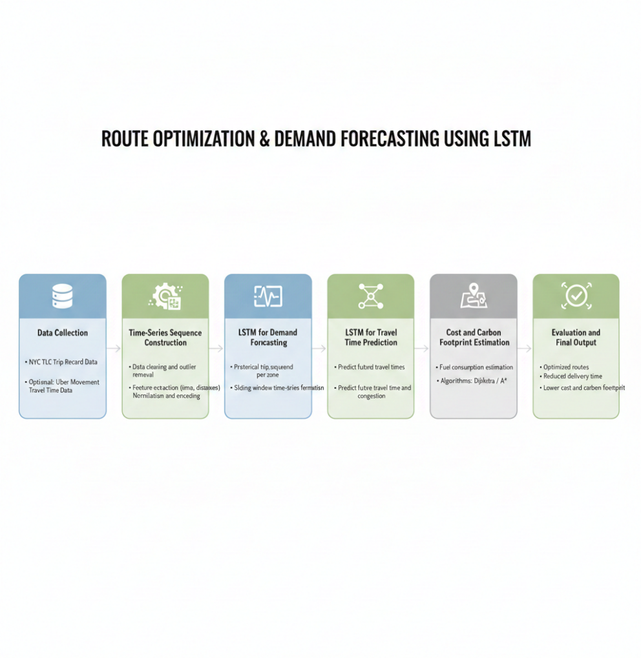
ARCHITECTURE OF LSTM

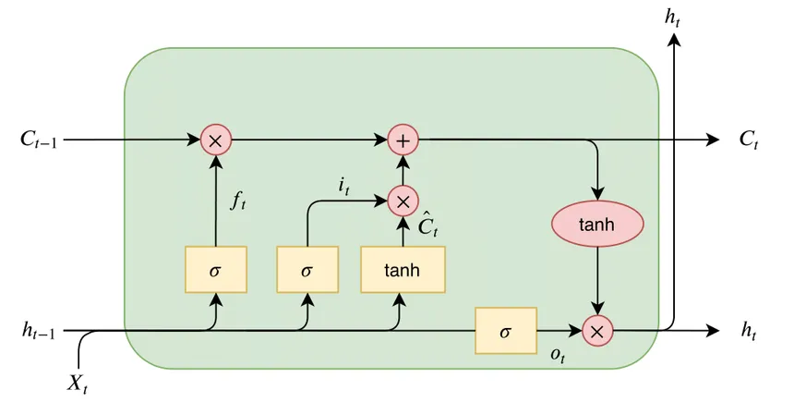

HYPERPARAMETER TABLE IN DATASET

Hyperparameter | Description | TLC Trip Data | Uber Movement Data
Input Features (D) | No. of features per time step | Pickup zone, drop zone, trip distance, duration, fare, congestion fee, time features | Road segment ID, avg speed, travel time, time-of-day
Sequence Length (T) | Past time steps used for prediction | 24, 48, 60 (hourly / daily patterns) | 12, 24 (short-term traffic trends)
LSTM Layers | Number of stacked LSTM layers | 1 – 2 | 1
Hidden Units (H) | Memory cells per layer | 64, 128 | 32, 64
Activation Function | Cell activation | tanh | tanh
Gate Activation | Input/forget/output gate activation | sigmoid | sigmoid
Dropout Rate | Prevents overfitting | 0.2 – 0.4 | 0.1 – 0.3
Recurrent Dropout | Dropout on recurrent state | 0.1 – 0.3 | 0.1 – 0.2
Optimizer | Weight update method | Adam | Adam
Learning Rate (η) | Step size | 0.001 | 0.001
Loss Function | Error metric | MSE / MAE | MSE
Batch Size | Sequences per batch | 32, 64 | 32
Epochs | Training iterations | 30 – 100 | 20 – 60
Validation Split | Validation data ratio | 0.2 | 0.2
Output Layer | Prediction layer | Dense (1): Demand / Travel Time | Dense (1): Segment Travel Time
Early Stopping | Stops overtraining | Enabled | Enabled

HYPERPARAMTERS IN LSTM

Hyperparameter | Description | Typical Value / Range
Input Features (D) | Number of input variables per time step (distance, time, zone, etc.) | 5 – 15
Sequence Length (T) | Number of past time steps used as input | 24, 48, 60
LSTM Layers | Number of stacked LSTM layers | 1 – 2
Hidden Units (H) | Memory units in each LSTM layer | 32, 64, 128
Activation Function | Activation used in LSTM cells | tanh
Gate Activation | Activation used in gates | sigmoid
Dropout Rate | Prevents overfitting | 0.2 – 0.5
Recurrent Dropout | Dropout on recurrent connections | 0.1 – 0.3
Optimizer | Optimization algorithm | Adam
Learning Rate (η) | Step size for weight updates | 0.001
Loss Function | Error metric for regression | MSE / MAE
Batch Size | Number of sequences per batch | 32, 64
Epochs | Number of training iterations | 30 – 100
Validation Split | Portion of data for validation | 0.2
Output Layer | Final prediction layer | Dense (1)
Early Stopping | Stops training on no improvement | Enabled

METRICS USED
Mean Absolute Error (MAE)
Measures the average absolute difference between predicted and actual values.
Why?
MAE provides a clear and interpretable measure of prediction error in real-world units (minutes for travel time, trips for demand), making it easy to understand model performance
Root Mean Squared Error (RMSE)
Measures the square root of the average squared prediction error.
Why?
RMSE penalizes larger errors more heavily, which is important for avoiding significant underestimation or overestimation of travel time and demand during peak hours.
Mean Absolute Percentage Error (MAPE)
Measures the average percentage error between predicted and actual values.
Why?
MAPE helps evaluate relative error performance across different traffic and demand scales, especially useful when comparing predictions across zones.
R² Score (Coefficient of Determination)
Indicates how well the model explains the variance in the data.
Why?
A higher R² value indicates that the LSTM model effectively captures temporal patterns in traffic and demand data.
Travel Time Reduction (%)
Compares baseline travel time with optimized route travel time.
Why?
This metric directly reflects the effectiveness of route optimization in reducing delivery time.
Cost Reduction (%)
Measures reduction in operational cost after optimization.
Why?
Helps quantify economic benefits achieved through improved routing decisions.
Carbon Emission Reduction (%)
Estimates the reduction in CO₂ emissions after route optimization.
Why?
This metric evaluates the environmental impact of the proposed approach, aligning with sustainability goals.

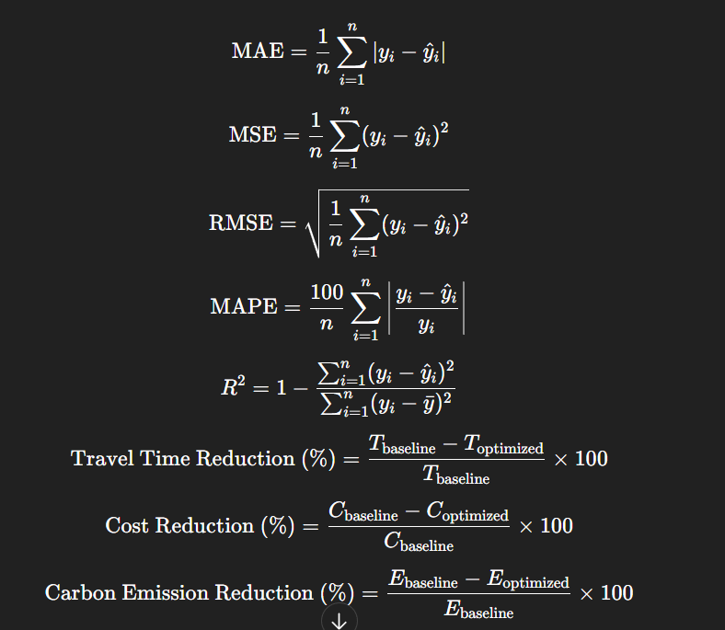

REFERENCES
Duan, Y., Lv, Y., Wang, F.-Y., “Travel Time Prediction with LSTM Neural Network,” Proceedings of the IEEE Intelligent Transportation Systems Conference (ITSC), 2016.
Sahin, U. (2022). A Deep Learning Approach to Forecasting Short-Term Taxi Demands. 2022 30th Signal Processing and Communications Applications Conference (SIU), 1–4. https://doi.org/10.1109/siu55565.2022.9864773
Luo, H., Cai, J., Zhang, K., Xie, R., & Zheng, L. (2020). A multi-task deep learning model for short-term taxi demand forecasting considering spatiotemporal dependences. Journal of Traffic and Transportation Engineering (English Edition), 8(1), 83–94. https://doi.org/10.1016/j.jtte.2019.07.002
IEEE Transactions on Intelligent Transportation Systems. (2013). IEEE Intelligent Transportation Systems Magazine, 5(3), 71. https://doi.org/10.1109/mits.2013.2265757

